The Conscious Framework: Experiential Scenarios and Cognitive Flow Architecture
The evolution of modern instructional design demands a decisive departure from the mechanized transfer of data. The contemporary educational landscape often mirrors industrial factory models, prioritizing behavioral compliance over profound intellectual or psychological growth. To rectify this, the Conscious Framework serves as a sovereign architectural blueprint, reimagining the pedagogical process as a cognitive flow system divided into three consecutive classes, or "lesser mysteries": Impact, Authority, and the Self.¹ At the center of this system is the integration of the Trinity standard, an operational philosophy that asserts instructional design must always take precedence over mere organizational structure or artificial intelligence integration.²
To navigate this psychological terrain, the framework utilizes the "Iron Road" isomorphism. The Iron Road is not a fictional construct, but an applied, structural methodology designed to manage extraneous cognitive load and ensure cognitive safety within the learning environment.² It provides a track upon which the educator and the student can safely journey through the wilderness of infinite information, establishing a shared reality that respects the complex interplay between the conscious intellect and the unconscious mind.⁴ The following analysis details the thirty-six experiential stages that comprise this total lesson, aligning the Hero's Journey with the ADDIE framework (Analysis, Design, Development, Implementation, Evaluation) to create an end-to-end autopoietic educational experience.² Each stage is anchored by a specific power word, articulated through a narrative scenario that teaches the underlying pedagogical message through applied experience, and followed by a Socratic inquiry designed for multimodal delivery.¹

Video 1: The Architecture of Impact
The core inquiry defining the first module investigates the exact nature of the impact an educator assumes control over when a student grants them influence.¹ This initial lesser mystery charts the delicate movement past a superficial, transactional system into a space of profound vulnerability. It requires the educator to relinquish the illusion of absolute control, ultimately earning the sacred consent required to alter another human being's worldview.
Stage | Hero's Journey Phase | Power Word | Cognitive State Transition | Pedagogical Focus (ADDIE)
1 | The Ordinary World | TRANSACTION | Ignorance to Dissonance | Baseline System Analysis
2 | Call to Adventure | SYMPTOM | Dissonance to Awareness | Needs Assessment
3 | Refusal of the Call | COMPLIANCE | Awareness to Regression | Institutional Constraint
4 | Meeting the Mentor | PRESENCE | Regression to Safety | Establishing the Iron Road
5 | Crossing the Threshold | VULNERABILITY | Safety to Exposure | Blueprint Design
6 | Tests, Allies, Enemies | DIAGNOSIS | Exposure to Clarity | Root Cause Analysis
7 | Approach to Inmost Cave | CONSENT | Clarity to Permission | Learner Alignment
8 | The Supreme Ordeal | SURRENDER | Permission to Release | Development Phase
9 | Seizing the Reward | CONNECTION | Release to Resonance | Implementation
10 | The Road Back | INFLUENCE | Resonance to Responsibility | Guided Practice
11 | Resurrection | EMPOWERMENT | Responsibility to Autonomy | Summative Evaluation
12 | Return with the Elixir | IMPACT | Autonomy to Evolution | Autopoietic Feedback

Stage 1: The Ordinary World
The Pedagogical Context: The baseline illusion of modern education is that it functions merely as an exchange of data. The curriculum is treated as a commercial commodity, establishing a transactional criteria that completely ignores the psychological framework of the learner.¹ The Experiential Scenario: The fluorescent lights hum over a grid of perfectly aligned, identical desks. The educator stands at the front of the room, distributing the syllabus with the rhythmic, emotionless efficiency of a bank teller processing a routine deposit.⁶ The words spoken are precise, measurable, and entirely devoid of life. The student accepts the paper, their eyes glazed, immediately recognizing the unspoken contract: memorize this specific data, reproduce it on command upon a standardized test, and receive a predetermined grade. The curriculum is treated not as a living, breathing landscape of human knowledge, but as a commercial exchange where behavioral compliance is the ultimate currency. In this space, the human soul is an irrelevant externality.⁷ There is no Iron Road here to guide true discovery; there is only a mechanical treadmill. The Socratic Inquiry & Silence: If education is merely the transfer of data, why does a mind surrounded by endless information still starve for genuine understanding? [Image Prompt: A perfectly aligned stack of blank, gray ledger books resting on a cold steel table under harsh lighting.] Binaural breath: Inhale the sterile, metallic air for four counts; exhale the heavy, suffocating weight of an unfulfilled obligation for six counts.

Stage 2: Call to Adventure
The Pedagogical Context: The educator must learn to see beyond the immediate academic symptom and recognize the hidden human reality beneath. Behavioral or academic failure is often a sub-optimal action generated by an unconscious utility trying to protect the organism from perceived harm.¹ The Experiential Scenario: Midway through a dense lecture on historical dates, a student in the third row rhythmically taps their pencil against the desk, staring blankly out the window. The educator’s initial, unexamined instinct is irritation at the disruption of the timeline. However, a sudden shift in perception occurs. The tapping is not an act of malicious defiance, nor is the failing grade on the previous exam a measure of the student's actual intellect. These are merely surface manifestations—distress flares fired from a deeply neglected inner world. The academic failure is a symptom of a profound cognitive dissonance, a silent plea indicating that the rigid environment has failed to connect with the student's living reality.¹ The Socratic Inquiry & Silence: What hidden human reality are we actively ignoring when we choose to blindly treat the academic symptom rather than investigating the underlying cause? [Image Prompt: A close-up of a single, vibrant green weed forcing its way through a jagged crack in a vast, dry concrete parking lot.] Binaural breath: Inhale the tension of the surface disruption; exhale deeply, sinking into the hidden, complex roots below the concrete.

Stage 3: Refusal of the Call
The Pedagogical Context: When faced with cognitive dissonance, the educator experiences the temptation to ignore the human element and simply enforce the institutional rule, retreating to the safety of absolute authority.¹ The Experiential Scenario: The temptation to retreat to the safety of institutional authority is overwhelming. The educator stops the lecture mid-sentence and sharply demands the student cease tapping and pay attention immediately. The student flinches, instantly dropping the pencil, their posture stiffening into an attitude of perfect, robotic obedience. The room falls dead silent.¹ Order is ostensibly restored, and the delivery of the syllabus continues. Yet, in securing this behavioral compliance, the educator realizes with a sinking feeling that they have entirely severed the intellectual connection. The student's eyes are now fixed on the board, but their mind has retreated behind a fortified psychological wall, safe from the violent disconnect of punitive instruction.⁹ The Socratic Inquiry & Silence: When we force compliance to maintain the illusion of order, what precious, fragile aspect of the student's internal ecosystem do we destroy in the process? [Image Prompt: A beautiful, wild falcon wearing a heavy, intricately crafted leather hood, perched motionlessly on a handler's gloved fist.] Binaural breath: Inhale the rigid, suffocating air of institutional constraint; exhale slowly, feeling the heavy armor of psychological defense settling over the chest.

Stage 4: Meeting the Mentor
The Pedagogical Context: The turning point requires an unspoken connection beyond the educator's ego. It demands the radical act of establishing true presence, signaling to the learner that the classroom is a safe space for their actual self to emerge.¹ The Experiential Scenario: The educator stops speaking. They slowly lower the textbook, stepping out from behind the physical and metaphorical barrier of the podium. They walk down the aisle and pause near the student's desk, not with the looming, threatening shadow of an institutional enforcer, but with the quiet, grounding stillness of a witness. The educator meets the student's gaze. In that fleeting second of true eye contact, the rigid, institutional roles of 'Teacher' and 'Student' completely evaporate.¹ What remains is an unspoken, profound acknowledgment between two human beings navigating the exact same complex existence. The educator's presence becomes a sanctuary. The Socratic Inquiry & Silence: How does the sheer gravity of our undivided, non-judgmental presence alter the psychological safety of the physical space we inhabit? Binaural breath: Inhale the quiet stillness of the present moment; exhale the static noise of expectation and institutional ego.

Stage 5: Crossing the Threshold
The Pedagogical Context: The threshold is crossed the exact moment the student's inner defenses drop. This vulnerability is the prerequisite for all genuine learning, as it loosens the conscious framework that normally routes input to a habitual, defensive response.¹ The Experiential Scenario: The silence lingers just long enough to be uncomfortable, but the educator holds the space, resisting the frantic urge to fill it with curriculum. The student looks down, the hardened, carefully constructed mask of indifference finally cracking. In a voice barely above a whisper, the student admits, "I don't know what I'm doing here. None of this makes sense to me." It is a terrifying threshold to cross. The inner defenses have dropped, leaving the student entirely exposed to potential ridicule or institutional punishment. By speaking their unvarnished truth, they have offered the educator the raw, unrefined material of their actual cognitive state. The Socratic Inquiry & Silence: What must we risk within ourselves to be worthy of catching the fragile truth a student offers when their armor finally falls? [Image Prompt: A thick, heavy iron door slowly swinging open to reveal a vast, starlit sky over a quiet, endless ocean.] Binaural breath: Inhale the sharp, cold air of terrifying exposure; exhale the long, shuddering relief of dropping a heavy, exhausting shield.

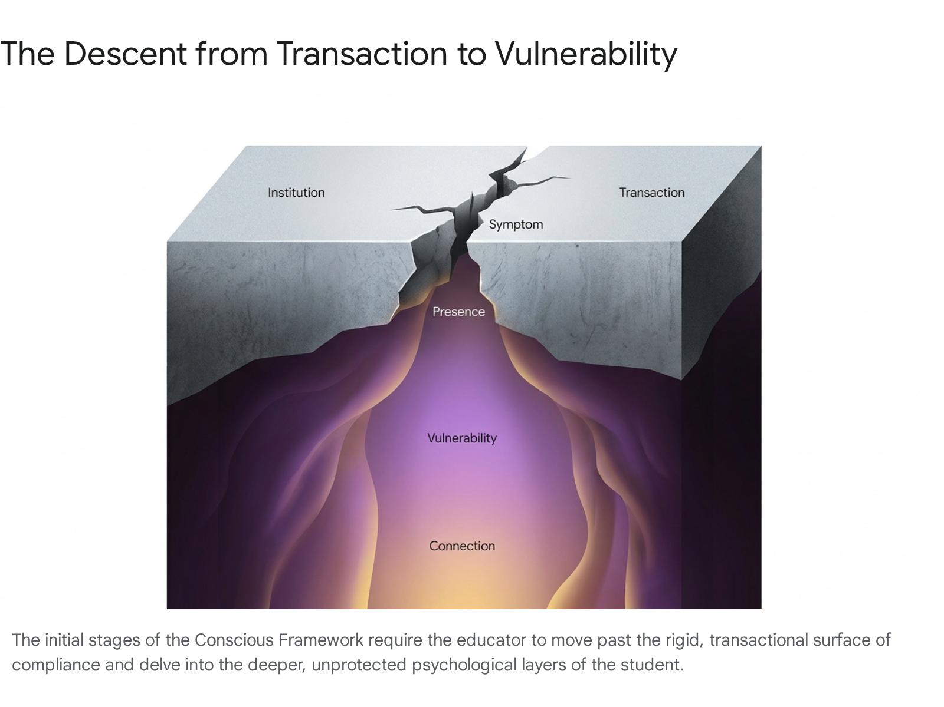

Stage 6: Tests, Allies, and Enemies
The Pedagogical Context: With defenses lowered, the educator must act as an analyst, looking past the confusion of the material to evaluate the root cause in the student's inner world, effectively engaging in the Analysis phase of the ADDIE framework.¹ The Experiential Scenario: Rather than addressing the student's quiet confession with a standard, mechanical academic remedy—a peer tutor, a highlighted study guide, or a remedial worksheet—the educator embarks on a much deeper line of inquiry. They sit down beside the student, engaging in a dialogue that maps the hidden contours of the student's frustration. The educator is looking past the confusion of the text to evaluate the root cause in the student's inner world.¹ They discover that the student's inability to grasp the historical timeline is not a failure of memory, but a protective cognitive mechanism shielding them from a pervasive, unconscious fear of moving forward in their own life.⁴ The true obstacle is successfully identified. The Socratic Inquiry & Silence: Are we courageous enough to diagnose the human condition staring back at us, rather than merely treating the superficial academic deficiency? [Image Prompt: A complex, glowing map of constellations being overlaid upon a chaotic, tangled web of dark threads.] Binaural breath: Inhale absolute clarity, visualizing a single thread untangling from a massive knot; exhale confusion, letting the tension dissolve into empty space.

Stage 7: Approach to the Inmost Cave
The Pedagogical Context: The educator cannot force a new perspective. They must wait for the internal permission slip the student must sign to allow the teacher into their cognitive framework.¹ The Experiential Scenario: Having identified the true psychological barrier, the educator does not forcefully dismantle it with unsolicited advice. Instead, they present their observation gently, laying it on the table between them without a shred of judgment. The educator asks, "Would you like to explore a different way to look at this?" The student pauses, intensely weighing the risk of trusting this guide against the ongoing pain of remaining stuck. A slow, deliberate nod follows. This is not the forced, resentful compliance of the syllabus; this is the sacred, internal permission slip the student must sign to allow the educator into their psychological framework.¹ The Socratic Inquiry & Silence: Why must true pedagogical intervention always wait patiently at the threshold of the student’s uncoerced invitation? Binaural breath: Inhale the profound weight of a genuine invitation; exhale the desire to force, control, or intrude upon another's mind.

Stage 8: The Supreme Ordeal
The Pedagogical Context: The educator faces their own ordeal: letting go of the illusion of control. They must realize they cannot force a mind to change; they can only provide the Iron Road and allow the student to travel it.¹ The Experiential Scenario: The educator introduces a new paradigm, a metaphor that perfectly bridges the abstract historical concept with the student's personal reality. But the student's brow furrows; the connection fails to ignite. The educator's ego surges, bringing a desperate, burning urge to explain it louder, to draw yet another diagram, to forcefully manifest the realization into existence. In this crucible, the educator experiences the supreme ordeal: letting go of the illusion of control.¹ They realize they cannot manufacture an epiphany within another mind. The educator surrenders, leaning back, embracing the heavy silence, and trusting the seeds they have planted in the student's cognitive soil. The Socratic Inquiry & Silence: What part of our ego must die when we finally accept that we are fundamentally powerless to force a student to learn? [Image Prompt: A single, vibrant autumn leaf detaching from a branch, suspended perfectly in mid-air against a gray, overcast sky.] Binaural breath: Inhale the deep realization of powerlessness; exhale the frantic, ego-driven need to control the outcome.

Stage 9: Seizing the Reward
The Pedagogical Context: True learning is born from a pure, human-to-human bond. When the conscious framework is sufficiently loosened, the unconscious arrives at something new, and the response emerges organically.¹ The Experiential Scenario: In the quiet, expansive space left by the educator's complete surrender, the student's mind is finally free from the crushing weight of external pressure. The habitual configurations loosen, allowing an unconscious search in the newly created psychological space.¹⁰ Suddenly, the student's eyes widen. They sit up straight, their voice energized and vibrant as they articulate the concept, not using the textbook's stale words, but their own. The circuit closes. It is a pure, human-to-human bond where true learning is born.¹ The reward is not the "right" answer, but the profound resonance of a mind awakening to its own innate capability. The Socratic Inquiry & Silence: How does the texture of knowledge change when it is discovered independently in a space of shared, silent trust? Binaural breath: Inhale the sudden, electric spark of understanding; exhale the lingering shadows of doubt and isolation.

Stage 10: The Road Back
The Pedagogical Context: The educator must integrate the heavy, sacred responsibility of altering another human’s reality and point of view.¹ They are laying the tracks of the Iron Road for the student's future progression.¹¹ The Experiential Scenario: As the class draws to a close, the educator reflects on the monumental shift that has just occurred. The student is packing their bag with a renewed, visible sense of purpose, their posture visibly lighter and more expansive. The educator feels a sudden, profound gravity settle over them. They have successfully altered another human’s reality and point of view.¹ This is not a triumph of pedagogical technique, but a heavy, sacred responsibility. To wield influence is to step onto the Iron Road of another's life, laying tracks that will dictate the direction of their future thoughts and actions for decades to come.² The Socratic Inquiry & Silence: Are we truly prepared to bear the immense ethical weight of the realities we create in the minds of those who trust us? [Image Prompt: A solitary figure standing at the precipice of a vast, ancient canyon, the wind carrying the sound of a distant, echoing river.] Binaural breath: Inhale the solemn weight of responsibility; exhale the fleeting, superficial pride of accomplishment.

Stage 11: Resurrection
The Pedagogical Context: The permanent shift in the student's Point of View indicates that the instructional design has been successfully implemented and integrated into the student's autonomous operating system.¹ The Experiential Scenario: The following day, the student encounters a complex, multi-layered problem that historically would have triggered an immediate psychological shutdown. The educator watches closely from a distance, fiercely resisting the urge to intervene and rescue. The student pauses, takes a deep breath, and autonomously applies the new cognitive framework they developed the day before. They dismantle the problem systematically. The change is not temporary; it is a permanent, structural shift in their Point of View.¹ The student has resurrected from the ashes of their former frustration, wielding a new cognitive tool that operates entirely independent of the teacher's presence. The Socratic Inquiry & Silence: How do we know we have truly succeeded as educators when the ultimate proof of our success is our own obsolescence in the student's life? [Image Prompt: A heavy blacksmith's hammer resting on an anvil beside a glowing, perfectly forged iron key.] Binaural breath: Inhale the quiet, unshakeable strength of self-sufficiency; exhale the lingering need for external validation.

Stage 12: Return with the Elixir
The Pedagogical Context: The realization that teaching is not about producing metric-driven results, but about holding space for the autopoietic evolution of the learner.¹ The Experiential Scenario: The semester finally ends. The educator looks out over the empty classroom, recognizing that the very air in the space feels fundamentally different than it did on the first day. They realize that the true elixir of their profession is not found in the production of high standardized test scores, but in the quiet, invisible mastery of holding space.¹ The educator has transcended the role of a teacher and become an architect of ecosystems, providing the sturdy Iron Road upon which students can safely journey toward their own becoming. The impact is invisible, unquantifiable, and eternal. The Socratic Inquiry & Silence: If our true impact can never be accurately measured by a spreadsheet or a metric, how do we evaluate the worth of our life's work? [Image Prompt: A vast, ancient forest viewed from above at dawn, the morning mist glowing with the first brilliant light of the sun.] Binaural breath: Inhale the vast, unmeasurable expanse of a life well-lived; exhale the narrow, suffocating confines of metrics and grades.

Video 2: The Architecture of Authority
The second module confronts the core question of who is truly in charge of the definition of truth, quality, and the expansion of perspective.¹ This arc outlines the perilous journey of relinquishing the teacher's ego as the absolute "Gatekeeper of Truth." It requires the educator to awaken the student as the ultimate sovereign author of meaning through the application of play, friction, and autonomy.
Stage | Hero's Journey Phase | Power Word | Authority Locus | Pedagogical Environment
1 | The Ordinary World | INSTITUTION | External (Institution) | Rigid, top-down dictates
2 | Call to Adventure | ABUNDANCE | External (Infinite) | Decentralized information
3 | Refusal of the Call | LABOR | External (Teacher) | Enforced, arduous work
4 | Meeting the Mentor | CURIOSITY | Internal (Emerging) | Self-driven interest
5 | Crossing the Threshold | PLAY | Internal (Exploration) | Sandbox without penalty
6 | Tests, Allies, Enemies | FRICTION | Internal (Testing) | Self-directed failure
7 | Approach to Inmost Cave | INITIATIVE | Internal (Navigation) | Mapping the unknown
8 | The Supreme Ordeal | MEANING | Internal (Synthesis) | Collision with the Self
9 | Seizing the Reward | OWNERSHIP | Internal (Possession) | Knowledge as property
10 | The Road Back | VALIDATION | Shared (Peer Level) | Honoring internal truth
11 | Resurrection | SOVEREIGNTY | Internal (Absolute) | Total self-governance
12 | Return with the Elixir | AUTHORITY | Internal (Ecosystem) | Sustainable autonomy

Stage 1: The Ordinary World
The Pedagogical Context: The traditional environment is a rigid structure where truth is dictated from the top down. The institution holds a monopoly on legitimacy, heavily restricting the cognitive load and flow of the learner.¹ The Experiential Scenario: The classroom operates as a perfectly sealed, closed system. The educator stands atop a metaphorical pedestal, acting as the sole, unquestioned distributor of sanctioned facts. The environment is rigid, built on an antiquated hierarchy where truth is dictated exclusively from the top down, and the student's role is merely to act as an empty receptacle.¹ Curiosity that strays beyond the narrow confines of the syllabus is politely ignored or actively suppressed, maintaining the structural integrity of the institution. The boundaries of the Iron Road are built so high and thick that the student cannot see the vast, vibrant landscape beyond the tracks.³ The Socratic Inquiry & Silence: When the institution violently demands that all truth must pass exclusively through its filter, what vast landscapes of human discovery are rendered permanently invisible? [Image Prompt: A massive, ornate iron gate, securely locked and rusting, blocking the view of a lush, infinitely overgrown garden.] Binaural breath: Inhale the suffocating dust of an ancient, closed archive; exhale the innate human desire to break the seal and explore.

Stage 2: Call to Adventure
The Pedagogical Context: The realization that information is infinite and free shatters the illusion of institutional monopoly. The educator must adapt to an environment of abundance rather than scarcity.¹ The Experiential Scenario: A student brings a personal device into the classroom and casually fact-checks a foundational premise the educator just delivered, finding a deeper, more nuanced counter-argument published by a global expert moments ago. The invisible walls of the closed system shatter instantly. The profound realization washes over the room that information is infinite, decentralized, and entirely free.¹ The role of the teacher as the primary source of data is instantly rendered obsolete. The concept of the Trinity 'Dispatcher' agent becomes a tangible reality—the student now has immediate, unfettered access to a boundless sea of subject matter experts and infinite variables.² The Socratic Inquiry & Silence: If high-quality information is everywhere and completely free, what is the actual, irreplaceable value that an educator provides in a space of infinite abundance? [Image Prompt: A single drop of water falling into a vast, endlessly rippling ocean beneath a cloudless, brilliant sky.] Binaural breath: Inhale the overwhelming, deafening rush of a million voices; exhale the desperate, futile attempt to silence the tide.

Stage 3: Refusal of the Call
The Pedagogical Context: Threatened by abundance, the educator experiences anxiety over losing authority, leading to the enforcement of meaningless labor disguised as academic rigor.¹ The Experiential Scenario: Deeply threatened by this sudden, uncontrollable abundance, the educator experiences acute anxiety over the terrifying loss of their authority. To frantically re-establish control, they double down on rigid structure, assigning dense, repetitive worksheets and mandatory, highly structured reading logs. They attempt to forcefully push "work" upon the student, tragically confusing arduous, exhausting labor with genuine rigorous learning.¹ The classroom degrades into a factory floor where the primary metric of success is the sheer volume of sweat equity expended, rather than the generation of actual insight. The Iron Road is weaponized into an exhausting treadmill of compliance.⁷ The Socratic Inquiry & Silence: Why do we so often disguise our own deep-seated fear of losing control as a righteous demand for student discipline and hard work? [Image Prompt: A heavy, rusted iron wheel being pushed endlessly in a circle, carving a deep, inescapable rut into dry earth.] Binaural breath: Inhale the exhausting, crushing weight of meaningless repetition; exhale the pervasive illusion that suffering equates to value.

Stage 4: Meeting the Mentor
The Pedagogical Context: True mentorship begins by recognizing the spark of self-driven interest that cannot be assigned or graded. The educator transitions from dictator to facilitator.¹ The Experiential Scenario: Amidst the soul-crushing drudgery of assigned labor, a student pauses, pointing to a tiny, tangential footnote hidden at the bottom of the text. They ask a question that has no correct answer in the teacher’s manual—a complex query born of genuine, unprompted interest. This is the elusive spark of self-driven curiosity that simply cannot be assigned, graded, or mandated.¹ The educator recognizes this fragile, beautiful ember. Instead of redirecting the student back to the mandated labor, the educator abandons the carefully constructed lesson plan entirely, becoming a true mentor who gently fans the flame of the student's intrinsic inquiry. The Socratic Inquiry & Silence: Are we truly willing to burn down the entire lesson plan just to illuminate the unmarked path a student’s genuine curiosity has just discovered? [Image Prompt: A small, brilliantly bright spark floating upwards in the pitch-black, oppressive darkness of a deep cave.] Binaural breath: Inhale the sudden, electric charge of a new, authentic question; exhale the rigid architecture of the planned agenda.

Stage 5: Crossing the Threshold
The Pedagogical Context: The student steps into the sandbox of serious, self-directed discovery. This requires an environment where institutional penalties are removed to allow for psychological flow.¹ The Experiential Scenario: The educator invites the student to explore the footnote further, providing sophisticated resources rather than simple answers. The student steps out of the rigid, punitive structure of 'schoolwork' and boldly crosses the threshold into the sandbox of serious, self-directed discovery.¹ There are no rigid rubrics here, no looming institutional penalties for being wrong. The student begins rapidly combining variables, building hypothetical models, and treating the knowledge not as a fragile artifact to be memorized, but as a robust toy to be aggressively dismantled. Learning ceases to be a heavy duty and transforms into a state of profound, highly engaged play. The Socratic Inquiry & Silence: What precisely happens to the architecture of fear in a classroom when failure is completely decoupled from penalty and reclassified as essential play? [Image Prompt: A chaotic, beautiful arrangement of brightly colored building blocks scattered across a sunlit wooden floor.] Binaural breath: Inhale the light, breathless energy of fearless exploration; exhale the heavy, dark fear of making a mistake.

Stage 6: Tests, Allies, and Enemies
The Pedagogical Context: The messy, beautiful process of self-directed failure and boundary testing. Friction is essential for cognitive development; it must not be prematurely resolved by the educator.¹ The Experiential Scenario: The student's playful exploration inevitably hits a massive wall. Their carefully constructed hypothesis collapses under the weight of contradictory evidence. Deep frustration mounts as they wrestle violently with the concepts. This is the messy, beautiful, essential process of self-directed failure and boundary testing.¹ The educator watches closely, fiercely resisting the overwhelming urge to step in and rescue the student. They deeply understand that this cognitive friction is the exact forge where true comprehension is tempered.¹³ The Iron Road requires the wheels to physically grip the rails; without friction, there is no forward momentum, only the useless spinning of wheels.² The Socratic Inquiry & Silence: How do we aggressively train ourselves to endure a student's struggle without stealing the vital, transformative lesson that only friction can teach? Binaural breath: Inhale the intense, burning heat of cognitive struggle; exhale the parental instinct to prematurely extinguish the fire.

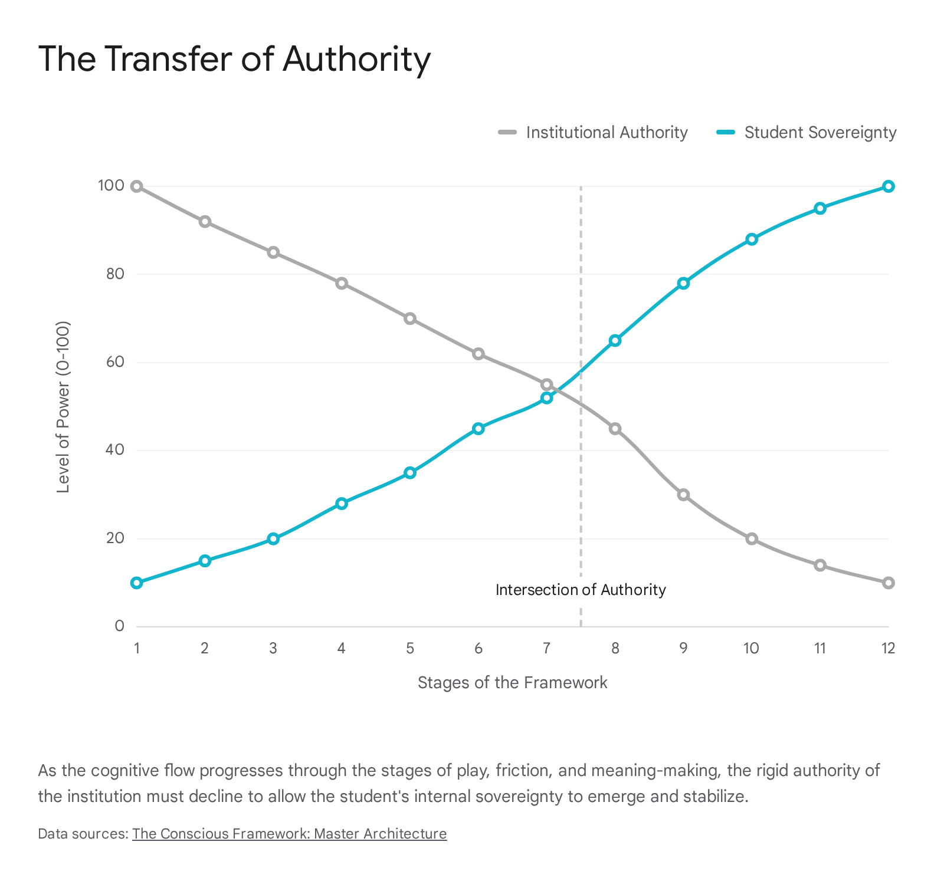

Stage 7: Approach to the Inmost Cave
The Pedagogical Context: The student takes charge of navigating the subject matter without a predefined map. They become the architect of their own cognitive load.¹ The Experiential Scenario: Emerging from the intense heat of the friction, the student does not sit back and wait for instructions. They independently pull a chair to a different workstation, open a completely new book, and begin mapping out a highly revised approach. They are now taking absolute, unprompted charge of navigating the subject matter without a predefined map.¹ The educator has become a mere, silent passenger on the student's cognitive journey. The student is charting their own Iron Road, laying the heavy track ahead of the train, driven entirely by an internal, unstoppable locomotive of purpose.¹⁴ The Socratic Inquiry & Silence: What is the exact psychological catalyst that transforms a passive receiver of instructions into a relentless, self-directed architect of their own learning? [Image Prompt: A highly polished compass resting on an old, blank parchment map, the needle vibrating slightly as it locks onto true north.] Binaural breath: Inhale the crisp, sharp focus of determined intent; exhale the lingering fog of hesitation and dependency.

Stage 8: The Supreme Ordeal
The Pedagogical Context: The exact moment the inert subject matter collides with the student’s "Self." This requires loosening the conscious framework to allow an unconscious search and integration.¹ The Experiential Scenario: The student suddenly connects the revised, complex data directly to their own life. A distant historical event perfectly mirrors a toxic dynamic in their own family; a complex scientific principle perfectly explains a confusing phenomenon they witnessed in their neighborhood. This is the supreme ordeal: the exact, explosive moment the inert, dead subject matter collides violently with the student’s living "Self".¹ The information crosses the blood-brain barrier. It is no longer abstract data; it is a profound revelation about the very nature of their own existence. The Conscious Framework has successfully suspended the old reality, and a massive new understanding has been forged.¹⁰ The Socratic Inquiry & Silence: How do we systematically construct environments volatile enough to allow dead information to collide with the living soul of the learner? [Image Prompt: A brilliantly colored nebula expanding violently in the deep vacuum of space, birthing completely new stars.] Binaural breath: Inhale the staggering weight of profound realization; exhale the hollow shell of meaningless memorization.

Stage 9: Seizing the Reward
The Pedagogical Context: The knowledge is no longer borrowed; it belongs to the student. They assume ownership of the intellectual property.¹ The Experiential Scenario: The student passionately presents their findings to the educator. The educator respectfully challenges a core premise to test the structure, but the student does not falter, apologize, or seek to simply please the teacher. They stand their ground firmly, citing evidence, and calmly defending their synthesized conclusion. The knowledge is no longer rented or borrowed from a textbook; it has been fully metabolized and now belongs entirely to the student.¹ They have seized the ultimate reward of intellectual property. Their understanding is an impenetrable fortress they built with their own hands. The Socratic Inquiry & Silence: When a student fiercely and accurately defends their own intellectual creation, how does the teacher survive the beautiful death of their own authority? [Image Prompt: A young, robust oak tree, its roots gripping deeply into a rocky cliffside, standing immovable against a strong wind.] Binaural breath: Inhale the unshakeable solidity of true conviction; exhale the fragile, desperate need for external approval.

Stage 10: The Road Back
The Pedagogical Context: The teacher recognizes and honors the student's internal truth, providing validation rather than grading.¹ The Experiential Scenario: The educator listens intently to the student's defense, nodding slowly. They do not offer a letter grade, a sticker, or a hollow, patronizing compliment. Instead, they offer a rigorous, peer-level validation. The educator explicitly recognizes and honors the student's internal truth, deeply acknowledging the depth of the work and the validity of the unique perspective.¹ This mature validation serves as the vital bridge back to the broader community, confirming that the student's solitary journey into meaning has resulted in something of genuine, undeniable value to the world. The Socratic Inquiry & Silence: What is the profound difference between dispensing praise to modify behavior and offering validation to honor a sovereign mind? Binaural breath: Inhale the profound peace of being truly seen and acknowledged; exhale the shallow noise of performative praise.

Stage 11: Resurrection
The Pedagogical Context: The definitive shift of power. The student claims absolute authority over their own perspective, demonstrating cognitive sovereignty.¹ The Experiential Scenario: The student sits quietly at their desk, methodically packing their materials. They look at the textbook differently now—not as a holy text of absolute, unquestionable truth, but merely as one flawed tool among many in their vast cognitive arsenal. The definitive shift of power has occurred. The student has claimed absolute authority over their own perspective.¹ They are now immune to arbitrary indoctrination, having developed the robust critical immune system required to navigate a world of infinite data. The student is resurrected as a completely autonomous intellectual entity. The Socratic Inquiry & Silence: If the ultimate, stated goal of education is total student sovereignty, why do so many institutions violently fight to retain their absolute control? [Image Prompt: A solitary king chess piece carved from pure white marble, standing alone in the center of an empty, vast chessboard.] Binaural breath: Inhale the limitless expanse of total self-governance; exhale the invisible, heavy chains of institutional dependency.

Stage 12: Return with the Elixir
The Pedagogical Context: Learning is put fully back into the student's hands. The system is evaluated as a self-sustaining ecosystem.¹ The Experiential Scenario: The educator steps entirely off the podium, walking to the back of the room and sitting in a standard student desk. The student approaches the board to explain their new paradigm to their peers. Learning has been put fully back into the hands of the learner.¹ The true, lasting elixir of this journey is the realization that authority is not a title bestowed by an institution, but a state of being earned through the rigorous, internal pursuit of meaning. The educational ecosystem is now entirely self-sustaining. The Socratic Inquiry & Silence: When the classroom is genuinely governed by the collective authority of sovereign learners, what entirely new worlds of possibility are finally unlocked? [Image Prompt: A sprawling, ancient library where every book is glowing with its own soft, internal light, with no librarian in sight.] Binaural breath: Inhale the vibrant, decentralized energy of shared wisdom; exhale the outdated ghost of the single, omniscient master.

Video 3: The Architecture of the Self
The final module explores the profound consequences of a fragmented curriculum. It investigates how the "Self" is impacted when the educational relationship neglects the physical, emotional, and experiential realities of the learner.¹ This arc charts the journey of healing the divided student, recognizing behavioral dissonance as a plea for space, and evolving the rigid classroom into a living, autopoietic community of grace.²
Stage | Hero's Journey Phase | Power Word | State of the Self | Ecosystem Intervention
1 | The Ordinary World | FRAGMENTATION | Divided/Severed | Enforced Separation
2 | Call to Adventure | DISSONANCE | Conflicted/Rebelling | Observing the Cry for Help
3 | Refusal of the Call | SUPPRESSION | Buried/Traumatized | Punitive Discipline
4 | Meeting the Mentor | GRACE | Seen/Acknowledged | Offering Unmerited Space
5 | Crossing the Threshold | ENVIRONMENT | Supported | Grooming the Habitat
6 | Tests, Allies, Enemies | SPACE | Expanding | Removing Judgment
7 | Approach to Inmost Cave | EXPERIENCE | Embodied | Engaging Physical Reality
8 | The Supreme Ordeal | INTEGRATION | Unifying | Fusing Emotion & Intellect
9 | Seizing the Reward | RESONANCE | Harmonized | Achieving Alignment
10 | The Road Back | STEWARDSHIP | Maintained | Tending the Ecosystem
11 | Resurrection | SELF-MASTERY | Regulated | Internalizing Discipline
12 | Return with the Elixir | EVOLUTION | Realized | Perpetual Growth

Stage 1: The Ordinary World
The Pedagogical Context: The violent disconnect of treating the student merely as a brain. This ignores the vast unconscious utility that manages vital functions and emotional states, leading to severe fragmentation.¹ The Experiential Scenario: The student walks through the classroom door and subconsciously leaves their physical body, their complex emotions, and their personal trauma in the hallway. They sit down at the desk, operating as a disembodied brain required only to process cold logic. This is the violent, normalized disconnect of traditional pedagogy: severing the intellect entirely from the biological and emotional realities of the human being.¹ The Conscious Framework is fractured; the conscious mind is forcefully engaged in the lesson, while the unconscious mind—desperately managing survival, fear, and physiological needs—is entirely ignored, brewing a massive, silent storm just below the surface.⁴ The Socratic Inquiry & Silence: When we demand a student bring only their intellect to the desk, what kind of profound psychological violence are we enacting upon their whole self? [Image Prompt: A beautiful, intricately painted porcelain mask lying shattered into jagged pieces on a cold, sterile tile floor.] Binaural breath: Inhale the sharp, jagged edges of a violently divided identity; exhale the exhausting effort of holding the fragments together.

Stage 2: Call to Adventure
The Pedagogical Context: Boredom, exhaustion, and confusion manifest as a cry for help from a neglected Self. The unconscious utility actively counters the conscious action, resulting in dissonance.¹ The Experiential Scenario: The deeply repressed unconscious mind inevitably begins to rebel violently against the sterile conscious framework.⁴ The student exhibits severe behavioral dissonance: suddenly acting out aggressively, displaying profound, unexplainable exhaustion, or collapsing into sudden tears. To the untrained, institutional eye, this is mere defiance. To the architect of the Conscious Framework, this is a literal cry for help—a sub-optimal action generated by the neglected Self to interrupt a system that is fundamentally detrimental to its vital functions.¹ The dissonance is an emergency flare signaling that the ecosystem has become toxic. The Socratic Inquiry & Silence: If we view disruptive behavior not as a personal attack on our authority, but as a desperate communication from a suffocating psyche, how must our response completely change? Binaural breath: Inhale the heavy, confusing static of internal conflict; exhale the instinct to immediately silence the noise.

Stage 3: Refusal of the Call
The Pedagogical Context: The institutional reflex is to label the student's pain as laziness and punish the symptom, enforcing suppression rather than addressing the root cause.¹ The Experiential Scenario: The institutional reflex kicks in with brutal, unthinking efficiency. The educator, tightly bound by policy, writes a referral, assigns detention, or publicly shames the student. They quickly label the profound psychological pain as "laziness" or "insubordination" and aggressively punish the symptom.¹ The cognitive cost imposed on the student is immense; they are forced to utilize all their remaining energy to push the trauma back down into the unconscious.⁴ The room regains its surface order, but the atmosphere is thick with a toxic, silent resentment. The Iron Road has become a prison wall, trapping the learner. The Socratic Inquiry & Silence: How much of our celebrated classroom management philosophy is actually just a highly sophisticated system for enforcing emotional suppression? [Image Prompt: A heavy, iron lid being forcefully screwed down onto a glass jar filled with violently swirling, dark smoke.] Binaural breath: Inhale the crushing, suffocating pressure of enforced silence; exhale the quiet, devastating retreat of the human soul.

Stage 4: Meeting the Mentor
The Pedagogical Context: The radical act of truly seeing and holding space for the whole human. This requires the suspension of the habitual response configuration to offer grace.¹ The Experiential Scenario: Instead of angrily reaching for the disciplinary referral, the educator completely pauses. They recognize the severe dissonance for what it is. The educator performs a radical act: they look deeply at the struggling student and offer pure, unmerited grace.¹ They say softly, "You seem incredibly overwhelmed today. You don't have to produce anything right now. Just breathe." The educator holds space for the whole human, acknowledging the validity of their emotional exhaustion without requiring a detailed explanation. The cycle of punitive instruction is broken, and a sanctuary is suddenly erected in the middle of the classroom. The Socratic Inquiry & Silence: What precisely happens to the shattered nervous system of a traumatized learner when they are met with grace instead of the punishment they were bracing for? [Image Prompt: A soft, warm beam of sunlight breaking through a dark, violently turbulent storm cloud to illuminate a single patch of calm ocean.] Binaural breath: Inhale the sudden, shocking warmth of undeserved compassion; exhale the tense, rigid armor of constant defense.

Stage 5: Crossing the Threshold
The Pedagogical Context: Shifting focus from the academic result to grooming the ecosystem. The educator becomes a steward of the environment rather than a manipulator of variables.¹ The Experiential Scenario: The educator makes a massive, conscious shift. They stop looking at the rigid lesson plan and start looking at the actual room. They deeply realize their primary job is not manipulating the academic result, but grooming the psychological and physical ecosystem.¹ They adjust the harsh lighting, change the physical layout to promote connection, and establish a tone of absolute psychological safety. The classroom permanently ceases to be a sterile container for data transmission and boldly crosses the threshold into becoming a living, breathing habitat designed to sustain human growth. The Socratic Inquiry & Silence: If a plant is wilting, we do not violently punish the leaf; we tend to the soil. Why do we treat human beings so differently? [Image Prompt: A pair of weathered hands gently packing rich, dark soil around the fragile roots of a newly planted sapling.] Binaural breath: Inhale the rich, grounding scent of fertile earth; exhale the sterile, artificial air of the institutional container.

Stage 6: Tests, Allies, and Enemies
The Pedagogical Context: Allowing the "Self" the literal and metaphorical room to exist without judgment. This space allows the unconscious to search and process.¹ The Experiential Scenario: The student naturally tests this new environment. They totally disengage from the lesson, putting their head down heavily on the desk. In the past, this would trigger an immediate confrontation. Now, the educator allows it. They give the "Self" the literal and metaphorical room to exist without any judgment.¹ This space is the ultimate test for the teacher's ego—to watch a student do 'nothing' and fiercely trust that critical, unconscious healing and processing are occurring in the dark.¹⁰ The space is the ally; the compulsion to constantly measure visible output is the enemy. The Socratic Inquiry & Silence: Are we truly capable of recognizing that sometimes the most profound educational intervention is simply leaving the student entirely alone? [Image Prompt: A vast, empty, silent desert under a canopy of brilliant stars, completely devoid of human architecture or movement.] Binaural breath: Inhale the vast, expansive freedom of non-expectation; exhale the frantic, buzzing need to constantly produce.

Stage 7: Approach to the Inmost Cave
The Pedagogical Context: Engaging the physical, mental, and emotional realities simultaneously. The curriculum is delivered as an applied experience rather than an abstract concept.¹ The Experiential Scenario: When the student is finally ready to lift their head, the educator does not hand them a makeup worksheet. Instead, they invite the student into an applied, immersive experience. They build a physical model, engage in a passionate debate, or walk outside to observe the phenomenon in nature. The pedagogy actively engages the physical body, the mental processing, and the emotional reality simultaneously.¹ The student is not merely studying a subject; they are living it. The flat, theoretical framework is entirely replaced by the visceral, undeniable texture of reality. The Socratic Inquiry & Silence: How do we effectively transition from teaching students about the world, to allowing them to directly experience the world within our walls? [Image Prompt: A pair of bare hands plunging into cold, rushing river water, fingers splayed to feel the intense kinetic energy of the current.] Binaural breath: Inhale the sharp, vivid texture of immediate physical reality; exhale the flat, gray abstraction of theoretical concepts.

Stage 8: The Supreme Ordeal
The Pedagogical Context: The profound process of pulling the fragmented pieces back together. Emotional regulation is fused with intellectual capacity.¹ The Experiential Scenario: Immersed deeply in the experience, the student encounters a moment that severely challenges both their intellect and their emotional resilience. They struggle, get intensely frustrated, and want to quit. But the environment is undeniably safe, and the experience is highly compelling. They take a deep breath and push through, utilizing their emotional regulation to sustain their cognitive focus.¹⁵ This is the supreme ordeal: the profound process of pulling the fragmented pieces of the self—the brain, the body, the heart—back together into a unified mechanism capable of overcoming severe adversity.¹ The Socratic Inquiry & Silence: What is the massive magnitude of power unleashed when a student finally aligns their emotional resilience with their intellectual capacity? [Image Prompt: Liquid gold being poured carefully into the cracks of a shattered ceramic bowl, binding the broken pieces into a stronger, beautiful whole.] Binaural breath: Inhale the warm, binding energy of internal unification; exhale the jagged, bleeding edges of a fragmented mind.

Stage 9: Seizing the Reward
The Pedagogical Context: The deep harmony when the student's identity aligns perfectly with their environment. The conscious and unconscious are in resonance.¹ The Experiential Scenario: The complex task is successfully completed. The student stands back, breathing heavily, feeling a deep, vibrating sense of genuine accomplishment. They look around the classroom and realize, for the first time, they truly belong here. Their identity aligns perfectly with the environment.¹ The severe dissonance is completely gone. The conscious framework and the unconscious drives are no longer at war; they are singing the exact same chord.⁴ The reward is a state of deep, harmonic resonance where the student feels entirely seen, fiercely capable, and intensely alive. The Socratic Inquiry & Silence: How do we architect spaces that vibrate at the exact frequency of human potential, causing the dormant soul to resonate powerfully in response? [Image Prompt: A massive, ancient bronze bell immediately after being struck, the air around it visibly shimmering with powerful, low-frequency sound waves.] Binaural breath: Inhale the deep, powerful vibration of total alignment; exhale the lingering static of internal discord.

Stage 10: The Road Back
The Pedagogical Context: Tending to the ecosystem instead of manipulating the behavior. The educator embraces the role of a steward.¹ The Experiential Scenario: The educator observes this beautiful resonance and internalizes a permanent shift in their own professional identity. They are no longer a commander or a data-transfer mechanism. They are a true steward. They walk the Road Back, formally committing to tending the ecosystem instead of manipulating the behavior.¹ Their daily work becomes a sacred act of vigilant observation, constantly adjusting the light, the nutrients, and the safe boundaries of the Iron Road to ensure the habitat remains conducive to the resonance they have witnessed. The Socratic Inquiry & Silence: What deep-seated arrogance must we shed to accept that we are merely gardeners tending the soil, rather than the creators of the flower? [Image Prompt: A worn, wooden watering can resting silently on a stone path next to a vibrant, thriving garden bed in the late afternoon sun.] Binaural breath: Inhale the quiet, humble dedication of a caretaker; exhale the grandiose illusion of being the master architect.

Stage 11: Resurrection
The Pedagogical Context: Internal regulation replacing external discipline. The student authors their own growth, independent of the institution.¹ The Experiential Scenario: A sudden conflict arises between two other students. The educator deliberately steps back. The student who previously exhibited severe dissonance intervenes. They take a deep breath, regulate their own emotional response flawlessly, and mediate the conflict with profound empathy and logic. Internal regulation has permanently replaced external discipline.¹ The student is actively authoring their own growth, utilizing the fully integrated Conscious Framework to navigate complex social and emotional terrain without relying on the authority of the institution. The student has achieved complete self-mastery. The Socratic Inquiry & Silence: If true discipline is entirely internal, how do we systematically dismantle our external structures of control to allow it to grow? [Image Prompt: A perfectly balanced stack of smooth river stones resting on a boulder amidst the chaotic, rushing white water of a mountain stream.] Binaural breath: Inhale the calm, immovable center of internal balance; exhale the chaotic, pulling currents of external reaction.

Stage 12: Return with the Elixir
The Pedagogical Context: The ultimate goal of true education—the fully realized, growing individual capable of perpetual evolution.¹ The Experiential Scenario: The student graduates and walks out the door. They are not merely leaving with a piece of paper certifying data retention; they are leaving as a fully realized, integrated human being. The educator remains, preparing the space to welcome the next cohort. The ultimate goal of true education has been definitively achieved.¹ The elixir is not a static state of knowledge, but the perpetual capacity for evolution. The Conscious Framework, guided strictly by the Trinity standard and traveling the secure Iron Road, has successfully shepherded the human soul through the mysteries of existence. The Socratic Inquiry & Silence: When the final bell rings, what exactly is the fundamental nature of the human being we release into the world? [Image Prompt: A vast, unending horizon at sunrise, the sky painted with limitless colors, an open road stretching forward into the brilliant light.] Binaural breath: Inhale the endless, unfolding potential of human evolution; exhale the final, fading echoes of the past.

Conclusion
The architecture of the Conscious Framework systematically dismantles the antiquated, industrial model of education. By carefully guiding the cognitive flow through the three lesser mysteries—Impact, Authority, and the Self—the system transitions the learner from a state of transactional compliance to a state of sovereign, integrated self-mastery. The utilization of the Iron Road isomorphism ensures that this journey, while profoundly disruptive and psychologically complex, remains structurally sound and cognitively safe for the learner. Ultimately, this paradigm demands a radical evolution not just in pedagogical technique, but in the fundamental spiritual posture of the educator. The work is no longer about teaching abstract subjects; it is about providing the sacred, robust architecture within which a human being can consciously and brilliantly author their own existence.

Works cited
- THE CONSCIOUS FRAMEWORK: MASTER ARCHITECTURE
- TRINITY_TECHNICAL_BIBLE.md
- The Iron Road in the Prairie State: The Story of Illinois Railroading by Simon Cordery | eBook | Barnes & Noble®, accessed May 15, 2026, https://www.barnesandnoble.com/w/the-iron-road-in-the-prairie-state-simon-cordery/1121958890
- A dynamic model of interactions between conscious and unconscious - Munich Personal RePEc Archive, accessed May 15, 2026, https://mpra.ub.uni-muenchen.de/36697/1/A_dynamic_model_of_interactions_between_conscious_and_unconscious.pdf
- Iron - Wikipedia, accessed May 15, 2026, https://en.wikipedia.org/wiki/Iron
- Untitled - Pécsi Tudományegyetem, accessed May 15, 2026, https://dok.pte.hu/sites/dok.pte.hu/files/2024-03/IDK2021_Tanulmanykotet_tomoritett.pdf
- Critique of Competitive Freedom and the Bourgeois-Democratic State - kritische Bildung, accessed May 15, 2026, https://kritischebildung.de/afkg/Eldred_State.pdf
- Vista do Humanismo inumano | Revista Sem Aspas - Portal de Periódicos FCLAr - Unesp, accessed May 15, 2026, https://periodicos.fclar.unesp.br/semaspas/article/view/17787/16288
- Lives Within Walls: The Personal and the Political | The AIDEM, accessed May 15, 2026, https://theaidem.com/en-lives-within-walls-the-personal-and-the-political/
- Reading List - James P. Dowling -, accessed May 15, 2026, https://jamespdowling.com/reading-list/
- The Iron Road of Progress – History of Cartography Project - UW-Madison Geography, accessed May 15, 2026, https://geography.wisc.edu/histcart/railroad-mapping/
- Monitoring of Mediterranean Coastal Areas. Problems and Measurement Techniques - CNR Solar, accessed May 15, 2026, http://eprints.bice.rm.cnr.it/20651/1/Monitoring.pdf
- “Pull” Your Ideas from the Ether | Jordan Cooper's Blog: startups, venture capital, etc, accessed May 15, 2026, https://jordancooper.blog/2010/03/25/pull-your-ideas-from-the-ether/
- The Iron Road: The Illustrated History of Railway, accessed May 15, 2026, http://136.175.10.10:8088/ebook/pdf/The_Iron_Road_The_Illustrated_History_of_Railways.pdf
- How the subconscious mind shapes interaction and relationships : r/socialskills - Reddit, accessed May 15, 2026, https://www.reddit.com/r/socialskills/comments/u8o1z7/how_the_subconscious_mind_shapes_interaction_and/

